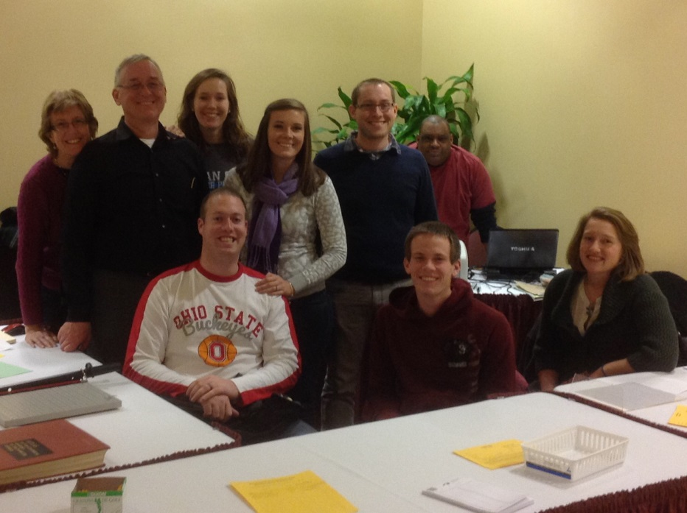

2014 Cardinal Report

The 37th edition of OCA’s Cardinal Open kicked off on January 24th in Columbus for the fifth straight year, organized once again by Grant Neilley and family. Myron Thomas served as chief TD. The field of 163 players included GM Dmitry Gurevich of Chicago, back for his third year, and three IMs: Ron Burnett of Kentucky, Goran Vojinovic of Serbia, and playing in his first US tournament, Atanas Kizov from Macedonia.

Turnout was down from last year when 194 participated, due in no small part to an untimely snow storm bringing icy conditions bad enough to close stretches of interstates for a time. Those who made it through the weather however, had high praise for the Embassy Suites Airport Hotel as our venue for the second time. While several players suggested shortening the games a bit as most other tournaments have done, many were quite vocal in their praise of the traditional 40/120 SD/60 time controls, perhaps contributing to the Cardinal’s success as well. Bonus rounds have been a popular feature at recent Cardinals; players completing their Saturday or Sunday morning rounds early had the chance to sign up for free extra rated games, played at G/75 while waiting for the next regular round to begin.

Local high school senior John Lodger Hughes turned in an impressive performance with an upset victory over GM Gurevich, repeating a feat he managed at the 2012 Cardinal as well. In the end, John tied for first with IM Kizov (4 points each), but won the first place bonus prize on tie breaks. His total prize of $1,150 (including the section upset prize) was quite a step up from his $33 winnings the year before. Third and fourth place prizes were shared in a four-way tie at 3.5 points by GM Gurevich, IM Burnett, IM Vojinovic, and Michigander, NM Edward Song. Bill Wright of Ohio also scored 3.5 points, but took the first place U2300 prize, with second place also split in a four–way tie among Alan Casden, John Stopa, Maggie Feng and Christopher Shen, all of central Ohio.

In the U2100 section, Ohioans Noah Keating-Adams and Sam Massick tied for first with 4.5 each. Third and fourth place prizes were shared by Jack Mo (PA), Jake Lennon (OH) and Benjamin Stern (IL), all half a point back at 4.0.

Surya Parasuraman (MI) took first in the U1800 with 4.5, followed by Dan O’Hanlon (WV), Shourjya Ghosh (OH) and Ben Tancinco (OH) at 4 each. Dan was returning to tournament play after a 13-year hiatus, and was surprised to find himself in such good form after such a long absence.

Brian Scheel-Ayers (MI) took first in the U1500, also with 4.5, improving on his third-place finish in U1300 the year before. Fred Schwan, Kian Souayvixay Dakshin Pinsini and Keith Myers, all of Ohio, split the remaining section prizes.

Prizes in the U1200 were swept by Ohio players, one of whom turned in the only perfect score of the tournament, Robert Miller IV. Katherine Lin and Jacob Sebastian tied for second with 4 points each, followed at 3.5 by Randall Julian and Kevin Marchese.

Upset prizes went to John Hughes in the Open with a 322-point spread in his win over Gurevich, Sam Massick in U2100 (230 points), Ayush Sunkad in U1800 (283 points), Aja Sampath in U1500 (312 points), and Chris Codogni in U1200 (248 points). There were actually larger upsets in the U1200, two by Kevin Marchese alone, but the prize was restricted to players with established (non-provisional) ratings.

21 players entered the Saturday night blitz, split into two sections and a round robin format. In the upper section, IM Burnett and local NM Carl Boor shared first place with 8.5 each out of a possible 9. Manis Davidovitch (MI) took third. In the lower section, it was another Ohio sweep with OSU grad student Boyi Gong taking first with 9.5 of 10, followed by Hazen Frick (9), Gregg Stark (8.5) and Vito Carla (8).

Saturday morning, OCA trustees gathered before rounds got underway to elect Cheryl Stagg as our new Treasurer and Membership Chair. She takes over for Sharon Driver who served in that role for several years.

Cross tables of the event are available on the USCF website, and prize distributions may be viewed at [www.neilley.com/chess](http://www.neilley.com/chess).

Continued feedback and suggestions are invited as we plan for next year. Mark your calendars for the next Cardinal to be held January 23-25, 2015, and invite your friends!